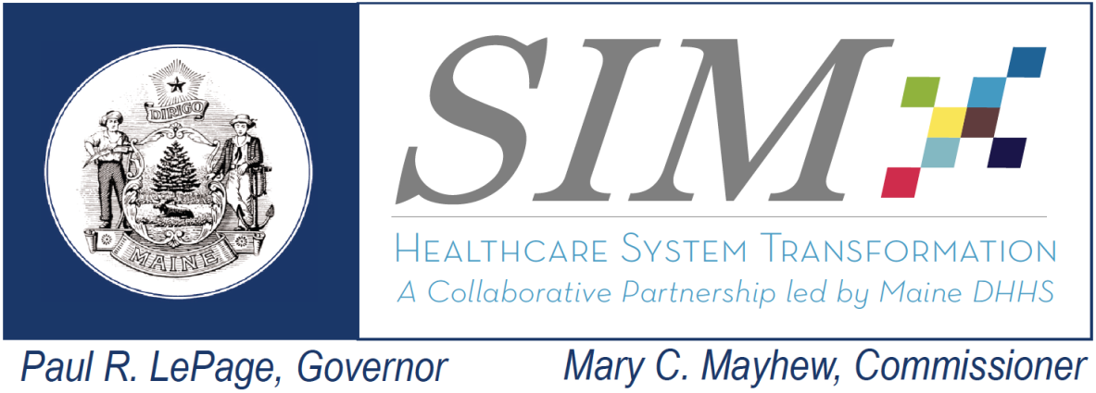 | SIM Steering Committee  Wednesday, December 10th , 2014  9:00am-12:00pm  Bank of Maine Ice Vault  203 Whitten Road  Hallowell

Attendance:
Noah Nesin, MD- via phone
Jay Yoe, PhD, DHHS – Continuous Quality Improvement
Randy Chenard, SIM Program Director
Dr. Kevin Flanigan, Medical Director, DHHS
Katie Fullam Harris, VP, Gov. and Emp. Relations, MaineHealth
Sara Sylvester, Administrator, Genesis Healthcare Oak Grove Center
Kristine Ossenfort, Anthem (via phone)
Deb Wigand, DHHS – Maine CDC
Jack Comart, Maine Equal Justice Partners- via phone
Rose Strout, MaineCare Member
Shaun Alfreds, COO, HIN
Fran Jensen, CMMI- via phone
Dale Hamilton, Executive Director, Community Health and Counseling Services
Penny Townsend, Wellness Manager, Cianbro
Lisa Letourneau, MD, Maine Quality Counts- excused

Interested Parties:
Katie Sendze- HIN
Lisa Tuttle- Maine Quality Counts
Frank Johnson, MHMC
Ellen Schneiter, MHMC
Andy McLean, MMA
James Leonard, OMS
David Hanig, Lewin
Andy Paradis, Lewin
Kathryn Vebina, Hanley
Peter Kraut, OMS
Kathy Woods, Lewin
Anne Conners, MQC
Lyndsay Sanborn, MHMC
Kathryn Pelletreau
Kathy Bustin, DRC/MCD

Absence:
Representative Richard Malaby
Representative Matthew Peter
Stefanie Nadeau, Director, OMS/DHHS
Andrew Webber, CEO, MHMC- excused
Lynn Duby, CEO, Crisis and Counseling Centers- excused
Rhonda Selvin, APRN
Eric Cioppa, Superintendent, Bureau of Insurance
Rebecca Arsenault, CEO, Franklin Memorial Hospital

All meeting documents available at: http://www.maine.gov/dhhs/oms/sim/steering/index.shtml
Agenda | Discussion/Decisions | Next Steps
1-Welcome – Minutes Review and Acceptance | Approve Steering Committee minutes from August Steering Committee meeting :  Minutes were adopted | Minutes will be sent for posting online.
2- Determine the need for development of a Statewide data interoperability roadmap | - Objective: Introduce to the Steering Committee the topic of utilizing the SIM Governance structure to develop a statewide data interoperability roadmap for recommendation to the State leadership  - Dr. Flanigan discussed Hunt Blair’s visit to the October meeting which focused on the creation of a roadmap to help with technology infrastructure. He explained that the MLT considered this to be a key part of what Maine needs, a data roadmap within the State. The Steering Committee was asked to think about what parts that we could ask the subcommittees/stakeholders/SIM partners to develop such a roadmap. They need to know what is in place currently and what the barriers could be. Shaun suggested that the Steering Committee start with the inventory that was done back in 2009. They had organized the development of a statewide HIT plan. Shaun offered to share the product of that effort to then be distributed to the Steering Committee members.  - Randy said that MLT was looking to Steering Committee for guidance on this topic and that it will be addressed in the February meeting. | Shaun will send product of 2009 efforts to create statewide HIT plan.  Randy will put this on the agenda for February’s meeting.
3- Lewin Group- Update and Overview of SIM Core Metric Dashboard example | - Objective: Lewin presentation will include highlights of their evaluation plan for Maine’s SIM grants as well as providing an example of the SIM core metric dashboard.  - Lewin Group, the in-State evaluators reviewed their PowerPoint presentation covering Maine’s SIM evaluation. It was explained that Maine will be evaluated on three key areas: Process & Implementation, Cost Effectiveness, and Impact & Effectiveness. They are working with two partners within the State of Maine, Crescendo and Market Decisions. Lewin is aware that there is evaluation fatigue and will be trying to reduce the replication of surveys.  - There was a lot of energy around the question of how data sets would carve out activities related to outside initiatives, like the Pioneer ACO, and activities/initiatives that are directly related to SIM. It was stated that they have already been working with MaineCare data and the populations reached by the Value Based Purchasing programs, but they haven’t received the commercial data yet and so can’t speak to that data until they are able to look at it. Dr. Yoe said there were a lot of confounding effects in play, but everything revolves around attribution and once they are able to access the commercial and Medicare data they should be able to tease apart the initiatives.  - There was also concern around what costs were being included in the evaluation, as residential and other similar services will be very expensive. Andy (from Lewin) said that the Evaluation Dashboard will be an important component of showing what is being captured, Evaluation Subcommittee will offer important input on that.  - It was explained that under SIM, the biggest player was MaineCare and their Health Homes/Accountable Communities programs. However, there were a few initiatives under SIM that touch the Medicare and Commercial populations and they are working having an interactive evaluation dashboard that will allow SIM governance to have an understanding of how they will be filtering out data from each SIM objective. There will be a lot of work going into separating SIM’s impact on these populations from the other ACA initiatives happening across Maine.  - Dr. Yoe said they are working hard on getting data pushed out as quickly as possible. They are already doing great with the MaineCare data, and are very hopeful to get other necessary data from MHMC/MHDO as soon as possible. It was stated that under SIM there are only funds for 3 years where some of the impacts won’t be able to be fully evaluated for 5 years, and how will Lewin be accounting for the 2 year difference. Lewin representatives said that they expectation is that they will be developing tools that can be used to make a track record for Maine. | As information and data become available from the SIM objectives, they will be shared with the Steering Committee.
4 - Leadership Development RFP Update | Objective: Inform Steering Committee on Leadership Development RFP  - Dr. Flanigan announced that Hanley was chosen from the Leadership Development RFP. They had put together an excellent product. | Steering Committee will be updated as this objective gets underway.
5 – Meaningful Consumer Involvement Presentation | Objective: Overview of presentation from consumer advocates regarding the importance of Meaningful Consumer involvement throughout SIM and other healthcare transformation work  - Lisa Tuttle explained that this risk had been identified in DSR subcommittee, and there was a small subgroup that completed the risk mitigation to define the risk and propose a mitigation strategy.  - Cathy Bustin, with help from Lydia Richards, came to the Steering Committee to give a presentation on what Meaningful Consumer Involvement means, the lack of it currently throughout SIM, and recommendations on how to remedy that issue.  - It was asked how “consumer” should actually be defined. Cathy answered that when in doubt ask the person how to “describe their expertise” as each label has the person’s history along with it. She stated that especially behavioral health recipients have a history of feeling powerless, because they can be held and treated against their will. It’s important to be inclusive and understanding of the history behind the label.  - There was discussion about how just having one consumer on the Steering Committee wouldn’t allow the message to reach to all constituencies. Randy agreed to that point, but stated that each person was asked to represent a demographic, in order to ensure that the committee didn’t become so large it that it would collapse upon itself. He gave the example that Katie Fullam-Harris was not there to represent MaineHealth, she was there to represent all large health systems and Kris Ossenfort wasn’t representing Anthem, but all commercial payers. Cathy said she understood, the important thing was to start taking steps in the right direction. She reviewed the recommendations that had come out of the subgroup working on the risk mitigation plan. Randy acknowledged that SIM has a lot of communication to do in the near future. | Group to present on Meaningful Consumer Involvement at SIM’s annual meeting in January.
6- Care Coordination (Risk 21) | Update on plans developed to address the Care Coordination risk by SIM Subcommittee Chairs  - There is a currently a small pilot project under development, using what already exists in HIN operationalizing key functions of care coordination. The pilot will include a Primary Care Health Home practice, a CCT, HIN, and Quality Counts. HIN is working to secure grant funding to build a Shared Care Plan component within its HIE. In the meantime they will be working to define this pilot.  - Dale Hamilton pointed out that they should have someone from OMS and someone from Licensing involved in the pilot from the very beginning because Licensing requires individual care plans at this point. Shaun agreed that they need to get perspectives from patient, providers, and regulatory entities. | Steering Committee will be updated on these efforts.
7- Core Measure Set Development Update | Update on the Core Measure set work being completed under the supervision of the Payment Reform Subcommittee  - Measure set is at 49 measures, and removing utilization measures brings list down to 39 measures. Have been working on figuring out how to aggregate this data for commercial population, issue should be resolved by the middle of January, 2015 depending on contract and renewal dates. Biggest issue with list is that they have to rely on claims based measures due to the difficulty of reporting on clinical data. MHMC will be working with health systems on identifying a few clinical measures that can be reported on like HBa1c. The goal is to eventually eliminated claims based measures and replace with clinical ones. They are also going to create a small workgroup to figure out how best to report on patient experience measures.  - It was explained that this work was not for public reporting, it is to be used for stakeholders. Dr. Flanigan reminded the Steering Committee that work done by MHMC for SIM, and the work done for their normal operations may look similar but there will be differences. Frank said that they will be presenting the measure set work to the Payment Reform Subcommittee for them to endorse and send on to the Steering Committee.  - Dr. Yoe asked what the ultimate goal is for SIM with this measure set. Frank explained that goal was to converge the measure sets in play. Katie Fullam-Harris further explained that it has been difficult to get providers to participate in payment reform efforts because measures are so vast and so different across payers. Frank said they want to establish a more clear direction for payers in order to advance payment reform. | Frank will share draft of measures with Steering Committee once the Payment Reform Subcommittee has endorsed it.
8- Public Comment | - No public comment.
9- Comments from Steering Committee Members | - Dale Hamilton asked for the mitigation plan for Risk 11- Business case for BHH providers due to rates. He said this is a significant issue and would like to be informed of any plan in place to address this. Dr. Flanigan said that MaineCare will review risk mitigation plan with Dale electronically and communicate it at February Steering Committee meeting.  - Rose addressed the issue around Shared-Decision making and the fact that many peers she knows are saying that they don’t want to make decisions, that the doctor should be making the decisions for them. Dr. Nesin further explained that doctors really don’t have the skill set to do shared decision making effectively, and there is a subset of patient pushback that wants the doctors to make all the decisions. It challenges providers to identify effective shared decision making tools.

